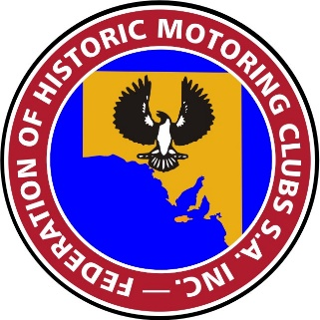
Federation of Historic Motoring Clubs
S. A. Incorporated
PO Box 703 Plympton S.A. 5038
Ph: 0417 847 944 www.fhmcsa.org.au
Founded 1971

LOGBOOK ISSUE & LOGBOOK RETURNS
REVISED PROCEDURE EFFECTIVE 26 November 2022

1. This procedure is issued to Clubs that are recognised under Motor Vehicles (Conditional Registration-Recognition of Motor Vehicle Clubs) Notice.

2. The Federation of Historic Motoring Clubs SA Inc is the issuing authority for Logbooks approved by the Registrar of Motor Vehicles for Club Registered Vehicles.

ORDERING OF LOG BOOKS
3. Logbook orders may be placed with the Log Book Manager either manually or on-line through our web-site. Please allow at least 15 working days for the processing of a manual order. However on-line orders have a quicker response as the order and payment details are received by the Log Book Manager immediately. Payments by cash, personal cheque or Club cheque may be made direct to any BankSA branch or at participating Post Offices quoting BSB 105-900 Account No 954046040. Please ensure the Bank quotes your Club name on the deposit.

4. The current fee for a log book is $2 for a Federation affiliated recognised club and $5 for a non-affiliated recognised club.

LOGBOOK RETURN SHEETS – Clause 2.30 of the Code of Practice
5. The submission of the old type logbook returns listing individual details against each logbook number has been discontinued effective 26 November 2022. Please refer to the Federation minutes of the meeting held on the same date. The return has been replaced by a Logbook Return Sheet Declaration. This declaration will operate from 1 July 2023 and will cover the preceding 12 months period. It will be required to be submitted annually thereafter covering each previous 12 months.

6. The style of the Declaration is attached to this procedure.

Shirley TONKIN
Secretary

(Please insert your Club’s Letterhead or name here).

The Logbook Manager
Federation of Historic Motoring Clubs SA Inc
P O Box 703
PLYMPTON SA 5038

LOGBOOK RETURN SHEET DECLARATION

In accordance with Clause 2.30 of the Code of Practice for Conditional Registration Scheme for Historic, Left-Hand Drive and Street Rod Vehicles (the Scheme), dated 1 July 2022;

I, _____________________________________________the Public Officer of the

___________________________________________ Club declares that Logbooks

were issued during the 12 month period ending on 30 June 20____.

I confirm that all Logbooks were issued to financial members who are owners of eligible vehicles registered under the scheme.

To the best of my knowledge the vehicles and Logbooks are being used in accordance with all conditions set out in the Code of Practice.

Signed: __________________________________Date: _____/____/_____
Public Officer

Please note:
This declaration to be forwarded to the Logbook Manager of the Federation of Historic Motoring Clubs either by an email containing this signed declaration to logbooks@fhmcsa.org.au , or posted to the above address.
Whichever method chosen, please ensure this declaration is received by 31 July each year.

